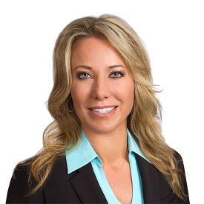 | 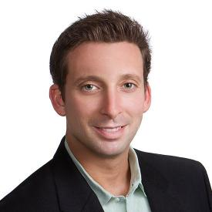
Andrea Bostic | Arlene Dickerson | Art Rodriguez | Becky Zeng
Bianca Briones | Brian Wu | Carlos Burgos | Carmen Eversdyk
Carmen Martinez | Celia Terry | Cindy Mendoza | Claire O'neal
Craig Holland | Dania Hamid | David Mosrie | Debbie DiCarlo
Dennys Digat | Doni Alexander | Hillary Smith | James Thomas
Jeff Thomas | Jeremy Smith | Joe Herrera | Jonathan Tyo
Juwon Lee | Kathleen Horne | Laura Ruiz | Luis Montemayor
Mang Ling | Marcelo Gonzalez | Maricruz Gutierrez (Suriff) | Mary Fitzpatrick
Matthew Berzins | Michael Isaac | Michael Omelanczuk | Mike Law
Pamela Berzins | Paul Lee | Peggy Goggans | Rebecca Stockhorst
Remi McDonnell | Robert Kraemer | Roberto Munoz | Salim Lakhani
Teresa Figg | Timothy Bartlett | Victor Daniello | Will Rodenbusch

